IT5016
Assessment 1:
Flow Chart and Pseudo Code
Name: Harbakshdeep Singh

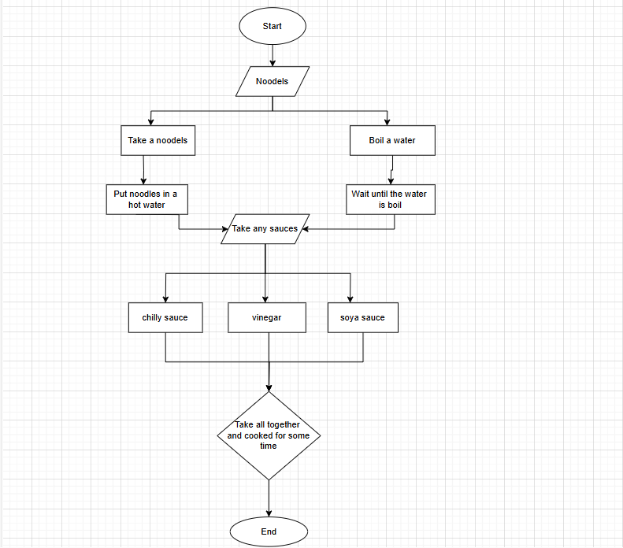

Pseudo Code
. First, we have to pick some packets of noodles.
. After that, we have to boil a water in the bowl.
. Put the noodles in that boil water.
. And, take some sauces, like chilly sauce, soya sauce.
. Last step, cooked for five to seven minutes.

